***Fantastic 6***

***Meeting Log***

**2.14.22**

***Details***:

1. Testing of discord and some of its features.

***To-do before next meeting:***

1. Think about which collaboration tool(s) we will use.

2. Develop user stories for product backlog.

3. Think about the overall vision for this software.

**2.18.22**

***Details:***

1. Settled on store’s theme: it will be multi-purpose, akin to amazon.

2. Settled on principle collaboration tools: google docs, google sheets.

3. Discussed and created a list of some use cases/user stories.

4. Discussed goals to try to accomplish before the next meeting.

***To-do before next meeting:***

1. Complete/revise product vision and send to prof.

2. Create a template for a weekly activities/sign-up sheet, so that we can have a log of what we each have individually done and so that we can be aware of the tasks that other teammates are working on.

3. Think about groupings for product backlog and work on consolidating some of the current stories.

**2.21.22**

**Details:**

1. Gave updates on previous tasks - revise PV statemented, activities sign-up sheet,

groupings.

1. Grouped essential user stories together and made a priority list

**To-do before next meeting:**

1. Choose a section in vision and scope doc to complete- 14 sections total(everyone does 2

sections. Write which ones you’ll be working on in “open task” excel sheet, see snapshot

below).

2. Complete the first 7 user stories (highlighted in green) in product backlog and move them

to sprint backlog (each person choose 1 or 2, write in excel master sheet->navigate to

“open tasks” on the bottom tab). See below for the snap shot of the Google sheet.

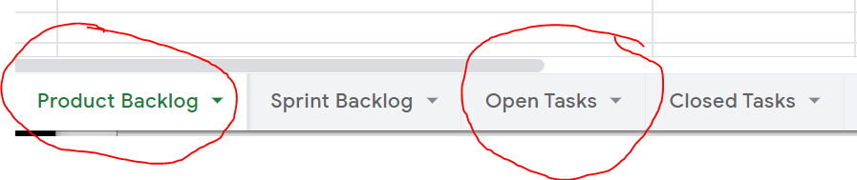

**2.25.22**

**Details:**

1. Updates given on our ‘Open Tasks’ and individual tasks that were signed-up for.

- Vision and Scope Doc sections

- Finishing first sprint (moving the first 7 user stories to the Sprint Backlog

2. 1st Sprint was deemed completed.

3. Discussed the remaining Use cases in the google doc that have not yet been

moved to the spreadsheet and organized them into Sprints.

**To-do before next meeting:**

1. Continue working on individual VS Doc sections.

2. Sign-up for remaining use cases and write stories for them in the Product Backlog.

**2.28.22**

**Details:**

1. Group gave updates on VS Doc.

2. Members gave updates on the status of the Product Backlog.

3. Confirmed organization of sprints and the stories that would be in each sprint.

**To-do before next meeting:**

1. Sign-up for 2nd sprint (2nd batch of user stories) and add them to the

Sprint Backlog.

2. Continue individual work on VS Doc.

**3.4.22**

**Details:**

1. Members discussed the 2nd sprint and updates on VS Doc.

2. Discussed organization of burndown charts.

**To-do before next meeting:**

1. Review each other's VS Doc entries.

2. Sign-up for 2nd sprint (3rd batch of user stories) and add them to the Sprint Backlog

**3.7.22**

**Details:**

1. Members discussed the 3nd sprint and updates on VS Doc.

2. 3rd sprint deemed completed.

**To-do before next meeting:**

1. Continue reviewing each other's VS Doc entries.

2. Sign-up for 4nd sprint (4rd batch of user stories) and add them to the Sprint Backlog.

3. Begin thinking about presentation organization.

**3.11.22**

**Details:**

1. Members discussed the 4th (final) sprint.

2. 4th sprint deemed completed.

3. Discussed how powerpoint will be divided.

4. Discussed things to still be finished - review of V/S doc.

5. Discussed assignment of powerpoint slides.

6. Settled on time to rehearse powerpoint: 17th of March, 10am

**To-do before next meeting:**

1. Work on individual powerpoint slides

2. Complete burndown charts (Fulya)

**3.14.22**

**Details:**

1. Members gave updates on slides.

2. Members discussed the review process for VS Doc.

**To-do before by Wednesday:**

1. Finish all slides.

2. Clean-up artifacts on Google Sheets

3. Finalize VS Doc

4. Practice individual presentation slides.